Virtual Drop-in with DPHS Counselors
Hello Students and Parents,
The DPHS Counseling Department will be hosting Virtual Drop-in sessions on Wednesday, August 19th from 4pm-5pm to meet with students to discuss schedules, answer general questions, meet with students/families, and etc.
To join us, just click on your assigned alpha Counselors Google Meet link below.
Mr. Limbrick  Last Names A - B  meet.google.com/wee-htbn-fhh | Mrs. Hernandez  Last Names C - De  meet.google.com/fdz-ezwg-rpb | 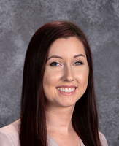  Ms. Stefanski  Last Names Df - Gn  meet.google.com/occ-yqew-egw
Mrs. Aspengren  Last Names Go - I  meet.google.com/hit-tejn-grx | Mr. Hawkins  Last Names J - Ma  meet.google.com/ojv-wbgm-ozb | Ms. Korth  Last Names Mb - O  meet.google.com/wvb-tvgy-mkb
Mr. Abid  Last Names P - Roj  meet.google.com/xxa-igmq-vyp | Mr. Parker  Last Names Rok - T  meet.google.com/sbd-tafw-pxw | 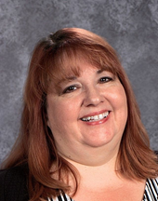  Ms. Matoza  Last Names U - Z  meet.google.com/tdn-qjvv-epe

