Desert Pines High School Counselors
2020-2021
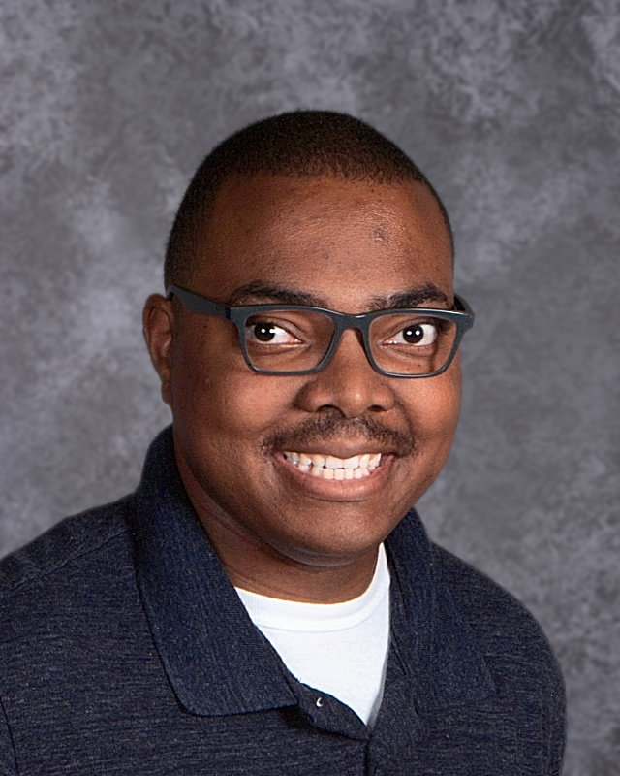  Mr. Limbrick  Last Names A - B  limbrld@nv.ccsd.net | 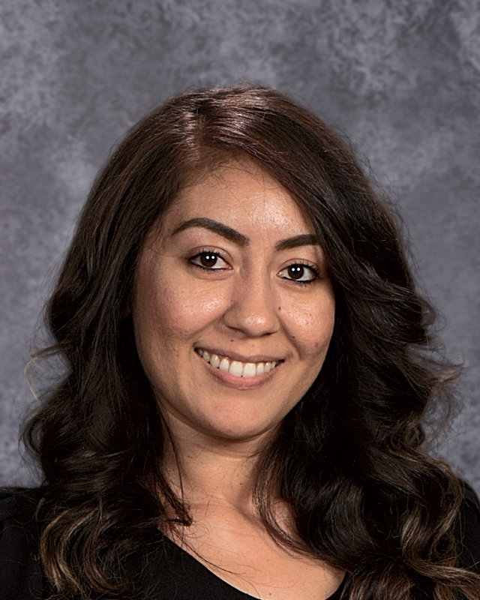  Ms. Hernandez  Last Names C - De  mercad1@nv.ccsd.net | 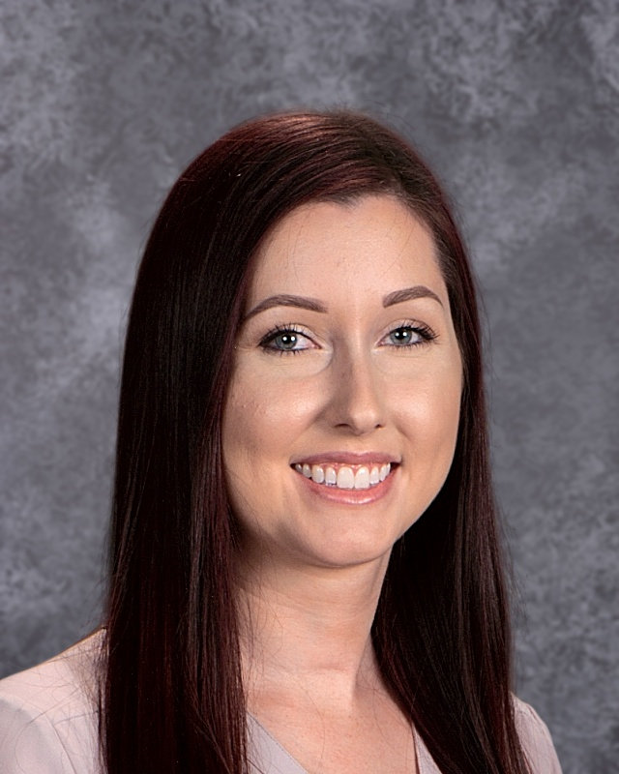  Ms. Stefanski  Last Names Df - Gn  stefas1@nv.ccsd.net
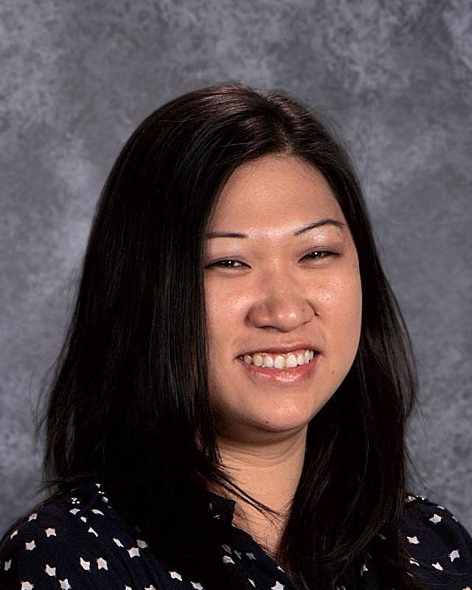  Ms. Aspengren  Last Names Go - I  aspeng@nv.ccsd.net | 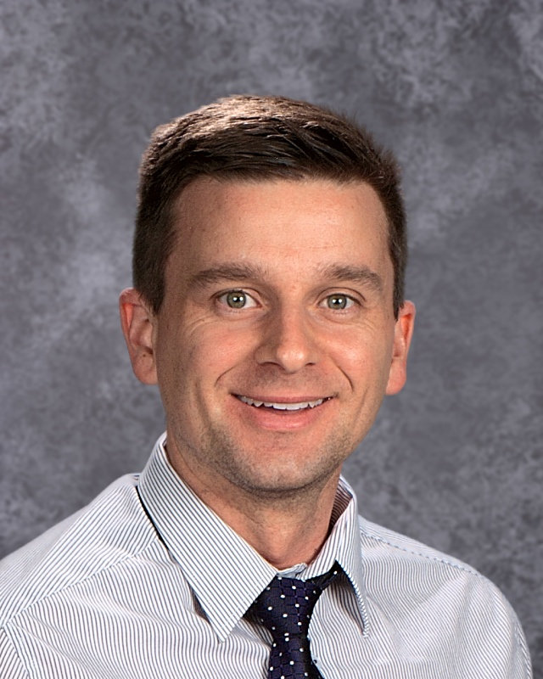  Mr. Hawkins  Last Names J - Ma  hawkigj@nv.ccsd.net | 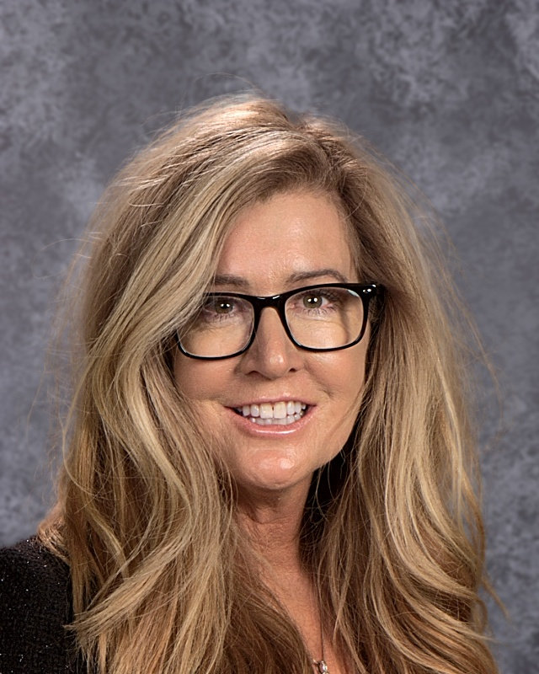  Ms. Korth  Last Names Mb - O  korthkb@nv.ccsd.net
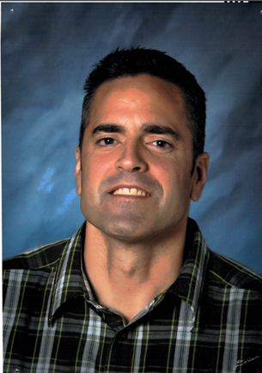  Mr. Abid  Last Names P - Roj  abidsr@nv.ccsd.net | 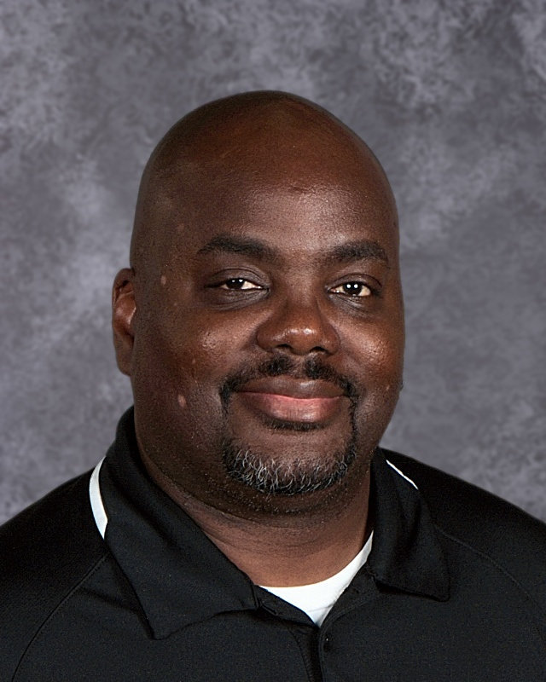  Mr. Parker  Last Names Rok - T  parkea1@nv.ccsd.net | 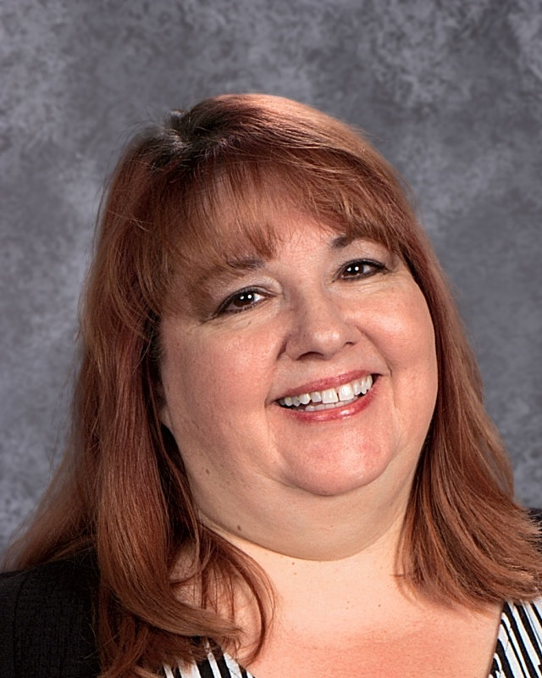  Ms. Matoza  Last Names U - Z  matoztm@nv.ccsd.net

